Deployable telescope

Satellite studied - PRISM

|  |  |
| --- | --- |
| LAUNCH | Jan. 23, 2009 |
| ORBIT | - Altitude: 660 km  - Eccentricity: 0.00  - Inclination: 98.06 deg |
| LAUNCH SIZE  (Picosatellite) | - 19cm x 19cm x 23cm (ONLY Body)  - 19cm x 19cm x 37cm      (INCLUDING boom) |
| WEIGHT | 8.5 kg |

Specifications of telescope(strain deployable) used in PRISM ( name of telescope was Collapsible Space Telescope)

|  |  |
| --- | --- |
| Aperture | 90 mm |
| Total mass (lens + boom) | 2 kg |
| Camera detector | IBIS-5A (Fill Factory) |
| Detector | CMOS type, size = 1280 x 1024 pixel |
| Ground resolution | 10 m / pixel |
| FOV (Field of View) | 0.6º, corresponding to a ground target size of 6.5 km x 6.5 km |
| Data quantization | 8 bit; ADC (analog digital conversion) of 10 bit |
| Volume | 13.8 * 20.3 * 7 cm3 |

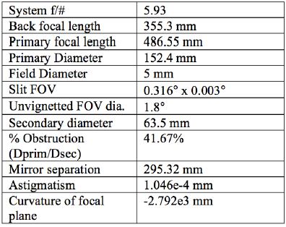

Primary mirror was from Orion Telescope. Secondary mirror was made by Optical Mechanics (Iowa, USA). The CMOS image detector is the IBIS-5A product of FillFactory NV (Mechelen, Belgium). To measure conic constant of primary mirror, Foucault test was done. Secondary mirror is diffraction limited at 65 nm.

PRISM is a box-type shape when launched so that PRISM can endure the launch vibration. After launch, PRISM transfer its mode step-by-step as listed below.

1. Released from the rocket on the orbit
2. Relesased form the POD and deploy the antenna for transmission
3. Deploy the receiving antennas
4. Deploy 4 solar panels to generate more power
5. Extend the telescope boom!

Prism has used a downlink system with a data rate (9600 bit/s). An onboard data compression technique is being employed (JPEG) to make image transmission feasible.

The method for imaging which we adopted for PRISM is not a "reflection-type" telescope, which general remote-sensing satellites use, but a ***"refraction-type"*** telescope. While a reflection-type telescope collects light *with a mirror*, a refraction-type telescope focuses light ***with a lens***. The advantage of this approach is that the optical system can be rather resistant to structure alteration. A simple refractive optical system requires a less stringent collimation accuracy with regard to alignment issues of the optical components - as compared to even the simplest reflective optical system. A reduction of chromatic aberration of the collector optics is achieved by using a fluorite apochromatic lens.

The bus consists of four columns and ten body panels, made of duralumin. Two deploying panels with solar cells are also made of the same metal alloy.

PRISM is three-axis stabilized with **ADCS** (Attitude Determination and Control Subsystem) to satisfy the requirements for imaging observations. The extensible boom design provides in fact a double function - to stabilize the spacecraft (passively as a gravity gradient boom), and to function as a placeholder for the primary lens of the optics subsystem (telescope). Magnetic torquers (MTQ) are used as actuators. Attitude sensing is provided by magnetometers, gyros, and sun sensors. In addition, WAC (Wide Angle Camera) is being used as an Earth sensor (horizon sensing). A GPS receiver provides location and timing data.

|  |  |
| --- | --- |
| C&DH CPU | - Use of CAN bus - SH7145F (Renesas Technology) - H8-3048F(Renesas Technology) - PIC-16F877(Microchip) |

• Power management system using PPT (Peak Power Tracking) techniques.

ADCS implements the following support functions:

• Capability of pointing the boom mounted lens toward nadir - in a predefined direction (steering function by attitude control)

• Provision of spacecraft attitude motion damping; this allows imagery of improved resolution.

Once the boom is deployed, ADCS steers the boom-mounted lens at Earth's surface. In case the attitude of PRISM is stabilized in the opposite direction, magnetic torquers securely recover the situation. The pointing accuracy calls for a few tens of a degree with a stability of 0.5º/s. 3 axis stabilization is also required for imaging.

The extensible boom concept comes with the following features:

• The boom is hollow tubular structure. There are no obstructions in the optical path when the deployment is completed.

• The boom is deployed using the concept of restoring force of elastic materials. This passive deploying mechanism makes the satellite's bus system compact and simple.

• The extended boom is provided with several baffles and shade curtains to reduce the effect of stray light collection.

• The optics subsystem has an onboard one dimensional focusing mechanism to optimize the focal length compensation (a micro stepping motor is used to avoid any degradation of the imagery). The flexible extensible boom is the key component for the mission. The GFRP (Glass Fiber Reinforced Polymer) frame plays a major role of the coiled spring, which pushes the lens and baffle plates out when the structure is unfolded and extended. Some threads are connecting the baffle plates to each other constraining each distance between them; they determine the total length of the boom. They also determine the relative position as well as the tilt angle of the lens toward the image sensor

Challenge –

1) Boom structure must be aligned accurately (i.e. optical path should not be obstructed)

2) It should remain thermally stable under various orbital lightning conditions.

3) Distance between back of primary mirror & system focus should be at least 6 cm.

4) A bore-sight repeatability of at least 100 microbar is required.

**Tests that should be done to ensure proper performance of deployment mechanism (I have taken these from Falconsat 7)**

1. Engineering model of deployment system (built by MMA design LLC, Boulder)
2. Zero-gravity deployment
3. After analyzing high speed footage, acceleration produced by each pantograph on each deployment can be calculated ( this showed that dynamics of deployment system were very repeatable)
4. System was tested in vacuum demonstrating that aero braking did not cause significant drag during deployments
5. Environmental Testing – A Qualification model of payload will undergo a sequence of sine-sweep/random vibration tests in a Cal-Polytest-POD on AFIT’s MB Dynamics slip table shaker. (to ensure survival of all components of payload in harsh vibration environment expected during launch)
6. Thermal vacuum test (first system exposed to high vacuum (1E-5 Torr) & a wide range of temp. (-45deg C to +45deg. C) & payload will be operated from bus to ensure full-functionality at all stages of this test to test its performance in space-like environment.

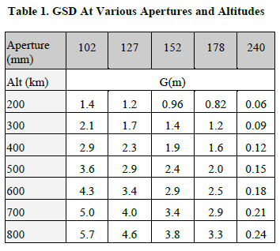

GSD (Ground Separation Distance) - The distance between 2 objects at which they can be identified as separate objects when observed from a distance. It is a measure of resolution.

FOV & maximum resolution is function of both the telescope configuration and the imaging sensor.